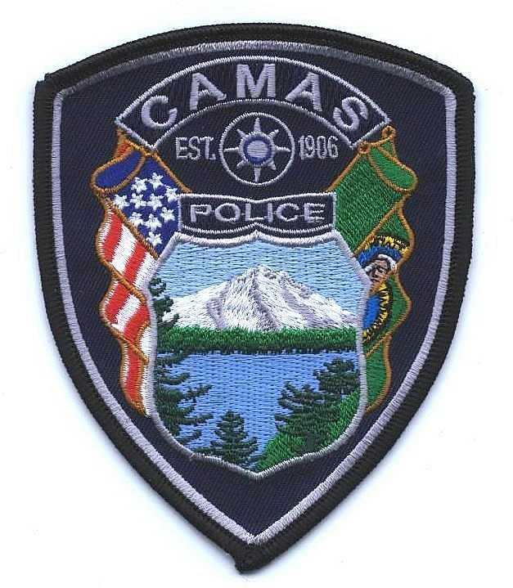
Camas Police Department
MEMO
March, 2020
To: Chief Lackey
From: Captain Nelson
Subject: Pursuit Review for 2019

There were three pursuit reviews in 2019, with each pursuit having a different initiating officer. The first pursuit involved a subject who was likely armed, had assaulted a deputy in Oregon and was in an interstate pursuit that came into Camas in a stolen vehicle. The second pursuit involved a suspected DUI driver. The third pursuit was initiated for a traffic infraction.

Administrative Review 19-01
Clark County agencies were advised by dispatch that a wanted subject who was armed and dangerous and had assaulted a deputy a couple of days prior was in pursuit from Oregon City into Washington. Dispatch advised the subject was actively wanted for Assault II. The pursuit involving both Oregon and Washington police agencies came into the City of Camas. One of our officer’s became involved with the pursuit which ultimately the suspect crashed into some trees and a fence in our jurisdiction. While there were no violations of the pursuit policy by the officer, there were some mistakes made related to Camas PD responsibilities for the crimes that occurred in our jurisdiction. The officer was counseled and training issues were identified/addressed.

Administrative Review 19-14
An officer initiated a pursuit of a suspected DUI driver. The pursuit was approximately one minute and the pursuit path was 1.5 miles. The driver crashed into a fence and fled on foot at a dead end street. A K-9 unit assisted with the apprehension of the driver (no dog bite). The driver received medical treatment and was booked on numerous charges (warrants, misdemeanors and felonies).

Administrative Review 19-40
An officer attempted a traffic stop for no front license plate and the driver was a known subject who had outstanding warrants and had previously evaded officers in a stolen vehicle. The officer also believed the vehicle in the attempted traffic stop was stolen. The total time of the pursuit was approximately 2 minutes 21 seconds. The distance of the pursuit was 2.5 miles. There was some discussion with the officer and supervisor on the concept of “fail to yield” versus a pursuit. This incident was a pursuit, which was ultimately terminated by the on duty sergeant and deemed to be within Department policy.

